ACO TP report

Group : Luc Powell
Course : M1 CSE
TP instructor : Marc Bousse

I. User stories
All of the User stories have a JUnit test associated. The tests are ordered and named accordingly.

1. As a user I can get the list of part categories (see table above) to select a category.
The category « Engine » correctly gives the following parts :
EG100, EG133, EG210 ED110, ED180, EH120.

2. As a user I can select a part variant for a given part category to put that part in the configuration.
The addition of a part to the configuration correctly adds it.

3. As a user I can see if my current configuration is valid or not, i.e. a configuration is invalid if and only it contains incompatible parts or does not contain all the parts required by part included in the configuration.
3.1) invalid configuration – Required Parts
the function verify() returns false when the configuration has a requirement that is not met.
3.2) invalid configuration – Incompatible Part
the function verify() returns false when the configuration has an incompatibility with another selected part.
3.2) valid configuration
the function verify() returns true when the configuration is valid.

4. As a user I can remove any part from the current configuration.
The removal of a part in the configuration correctly removes it.

5. As an application admin I can edit the set of incompatible parts and required part stored in the application.
It is supposed the user cannot add multiple motors.

5.1) Add incompatibility
The addition of an incompatibility correctly adds it to the list and is immediately taken into account.
5.2) Add requirement
The addition of a requirement correctly adds it to the list and is immediately taken into account.
5.3) Remove incompatibility
The removal of an incompatibility correctly adds it to the list and is immediately taken into account.
5.4) Remove requirement
The addition of an incompatibility correctly adds it to the list and is immediately taken into account.

6. As a user I can get an HTML description of my configuration, if it is complete and valid.
The content of the HTML is file is correct and readable by a browser.

7. As a user I can get the current price (in euros) of my configuration, even if it is incomplete (but it must be valid).
The price is correctly given even if the configuration is incomplete.

8. As a user I can select the colour of the exterior paint, from a limited subset provided by the application (the subset can depend on the exterior part type that I have selected).
The colour can be changed and is taken into account by the system. It is supposed the user cannot enter a colour that is not being displayed by the interface,

2 Schematics

1. Use case diagram
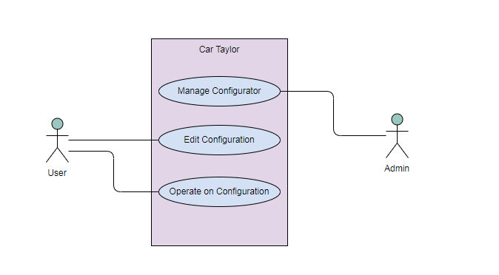

2. Class Diagram
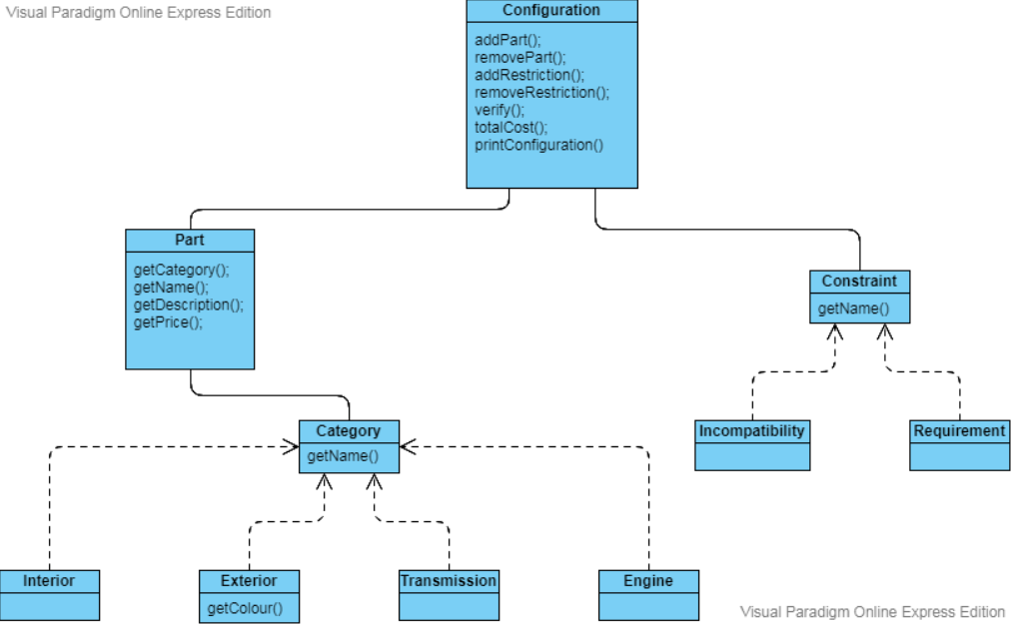

3. Sequence Diagram for printDescription()
